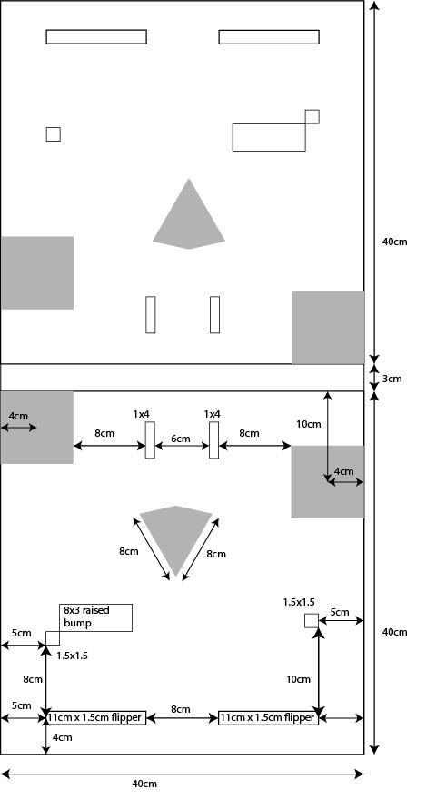

Figure

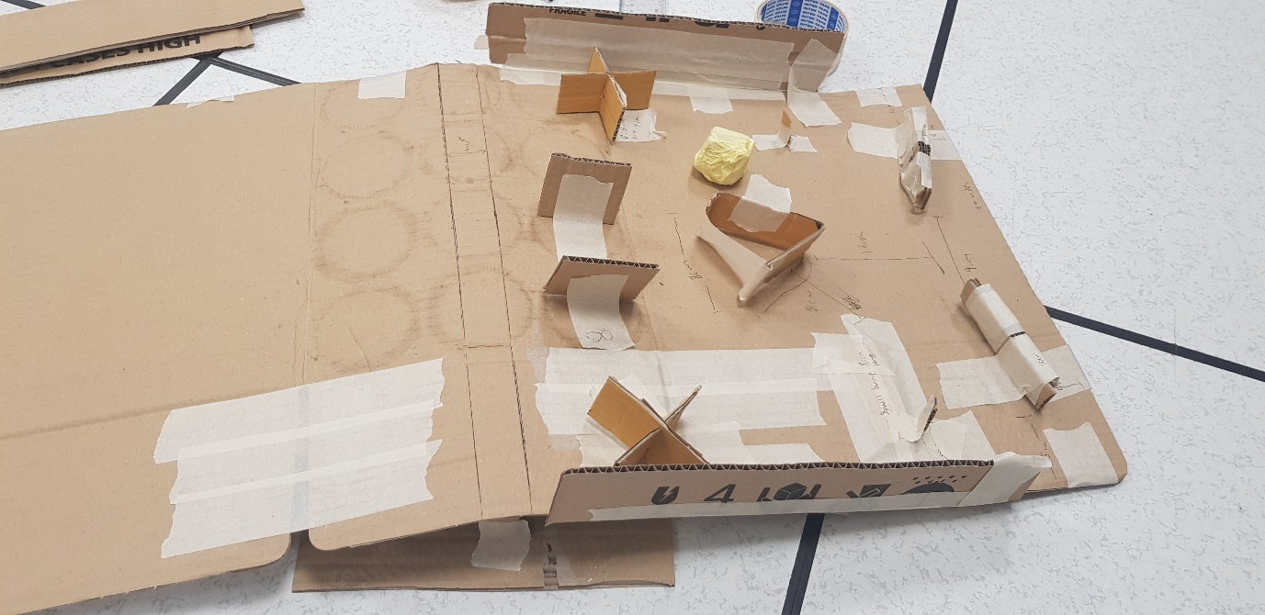

Figure

The entire board will be in the shape of an A-frame slightly tilted toward each side and flat in the middle to allow the ball to roll down on each respective side. The highest point of elevation of the flat middle is 5cm. This allows for a 7-degree incline which is just nice to prevent the ball from rolling too fast. Depending on the ball size selected, the obstacles are subject to change. The current design uses a ping pong ball of standard diameter 4cm as the ball size.

As obstacles are subject to change based on selection of ball, first order of business will be to select the ball and hence determine which type of flippers are strong enough.

Flippers:

If servo:

1x PCA9685 driver ($3)

4x servos ($3 each)

Total - $15

If DC Motor:

2x L298N driver ($2.50 each)

8x Limit Switch ($2.50 for 10)

4x DC Motor ($2 each)

Total - $15.50

If Solenoid:

2x 2N2222A Transistor ($0.50 each)

4x Solenoid ($4 each)

Total - $17

As we can initially see, the best option would be the servo as it is the cheapest. However, the push strength of the servo may not be enough and tests will need to be carried out.